Pokhara University

Level: Bachelor | Semester – Spring | Year : 2009
Programme: BE |  | Full Marks : 100
 |  | Pass Mark : 45
Course: Signal and System |  | Time : 3 hrs

Candidates are required to give their answers in their own words as far as practicable.
The figures in the margin indicate full marks.

Attempt all the questions.

1. | - What is dirac delta function? Explain properties of delta function.  - Check whether the following signal is power signal or an energy signal or neither: 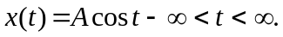  - Define odd and even signals. Derive any arbitrary signal in terms of its odd and even parts. | 5  5  5
2. | - The following fig. shows the sawtooth waveform. Find the Fourier series for this waveform. Also plot the magnitude and phase spectrum of the signal.  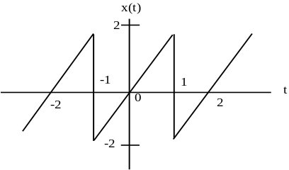  - Prove that, when two Fourier transforms are multiplied in frequency domain, then they are transformed into the convolution of their individual signal in discrete-time domain. | 8  7
3. | - Find the Fourier transform of the triangular pulse x(t) as shown in fig. 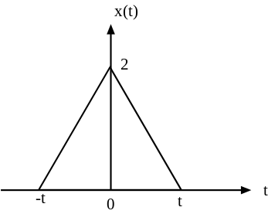  - Define Autocorrelation. State and prove Parseval's theorem for finite energy signals. | 9  6
4. | - Define discrete Fourier transform (DFT). How does it differ form discrete Time Fourier transform (DTFT)?  - Determine the circular convolution of the sequence. | 8  7
5. | - Define LTI system. Explain the properties of an LTI system.  - If a system has impulse response h[n] = {2,4,1} and input x[n] = {0,1,2}. Find out response of the system to x[n]. | 8  7
6. | - Design an equalizer for the multipath propagation system given by y(t) = 0.4x(t-t₁)+0.7x(t-t₂), such that the output is distortionless.  - Construct the Direct form I and form II (canonical structure) of an LTI system described by difference equation given below: | 8  7
7. | Write short notes on (Any Two):  - Application of FFT  - Gate and Signum Function  - IIR and FIR System | 2×5

